الأسم: سجا هاني رضوان رقم الطالبة: 20143578

Coarse Dispersion, suspensions

**إشراف الدكتور:**

**د. رياض القدرة**

OutLines:

* Introduction
* Classifications
* Physical Features of the dispersed phase
* Flocculation and deflocculation
* Quantitative expression of sedimentation and flocculation
* Formulation of suspension
* Controlled flocculation.

# Introduction

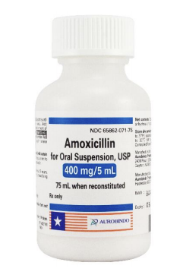

* A pharmaceutical suspension may be defined as a coarse dispersion containing finely divided insoluble material suspended in a liquid medium.
* In this preparation, the substance distributed is referred to as the dispersed phase ( solid particles ), and the vehicle is termed as continuous phase or dispersion medium.
* Coarse dispersion 10 to 50 µm
* Fine dispersions 0.5 to 10 µm
* Particles < 5 µm show Brownian movement
* They could be:
* Oral suspension
* For oral suspension

Why suspensions ?

* Certain drugs are chemically unstable in solution but stable when suspended.
* Ease of swallowing liquids
* The disadvantage of a disagreeable taste of a certain drug in solution form is overcome.
* Suspensions offer a way to provide sustained release.

Features desired in a pharmaceutical suspension

* Therapeutic efficacy, chemical stability and aesthetic appeal of the preparation.
* It should settle slowly and should be readily redispersed upon gentle shaking of the container.
* The particles that do settle to the bottom of the container should not pack into a hard cake.
* The suspension should pour readily and evenly from its container.

Classification

* Oral Suspensions: like antibiotics, antacid, NSAIDs.
* Topical Suspensions: like calamine lotion
* Sterile Suspension:
* Sterile suspension includes parenteral and ophthalmic
* An important property of a good parenteral suspension is syringeability.
* Increase in vehicle viscosity, and size and concentration of suspended particles make the transfer more difficult.
* Cosmetic Suspensions:
* Pigmented products that are suspended in essentially aqueous vehicles ( liquid makeup, eyeliners and mascara )
* The second type comprises pigment-containing nail enamels.
* Rectal suspension:
* Barium Sulfate for Suspension is used for diagnostic visualization of the GIT.
* Mesalamine (5-aminosalicylic acid) for treatment of Crohn disease, ulcerative colitis.
* Non aqueous suspensions
* Suspension of a water-soluble drug in a nonaqueous vehicle may provide a means to prepare a liquid formulation of a drug that has poor long-term stability in aqueous solution.
* Dispersions of drugs on oleaginous vehicles can also provide a sustained release form of drug as observed with certain depot injections.

Physical features of the dispersed phase

* Stokes’ law, expressed as:



* P1 the density of the particle and P0 is the density of the medium
* The Stokes equation does not apply precisely to the usual pharmaceutical suspension
* The Stokes equation was derived from an ideal situation in which:
* Uniform, perfectly spherical particles in a very dilute suspension settle without producing turbulence
* Without colliding with other particles of the suspensoid
* Without chemical or physical attraction or affinity for the dispersion medium.
* The most important consideration in a discussion of suspensions is the size of the particles.
* Particle size reduction is accomplished by dry milling i.e. micropulverization.
* Too much particle size reduction is discouraged.
* Comminution **→ ↓** particle size and **↑** surface area

Particle-Vehicle Interactions



Energy erg. = interfacial tension dyne/cm * surface area cm^2.

* The smaller  is, the more thermodynamically stable is the suspension of particles.
* Surface free energy could be minimized with decreased interfacial tension.
* How to decrease interfacial tension ?
* Powders that are wetted with difficulty by the vehicle are called lyophobic.
* The lyophobic powders tend to clump and float on the surface of the vehicle as sulfur in water.

Particle-Particle Interaction

* Attraction and repulsion between particles result from forces that reside at the particle surface.
* The source of the charge on particles may arise because of:
* Ionisable groups on their surfaces
* Because of adsorption of ions from surrounding solution.
* Generally the particles will all bear either a negative or a positive charge
* The electrostatic repulsion thereby setup between adjacent particles prevents them from adhering to one another

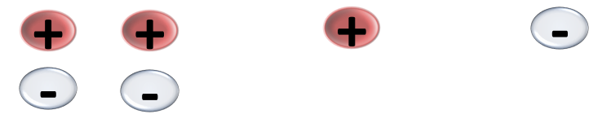

* The surface of the particle can also become solvated, which, in turn, helps to prevent particles coming together.

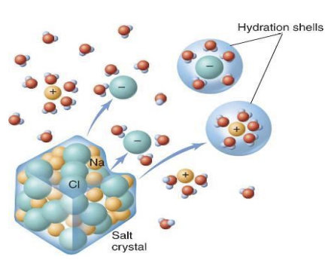

* Also vigorous agitation and the addition of certain protective polymers may lead to a deflocculated system.

Flocculation and deflocculation

* When zeta potential is relatively high (25 mV or more), the repulsive forces between two particles exceed the attractive London forces.
* The particles are dispersed and are said to be deflocculated.
* With decreased zeta potential, the particles may approach each other more closely and form loose aggregates, termed flocs.
* Such a system is said to be flocculated.

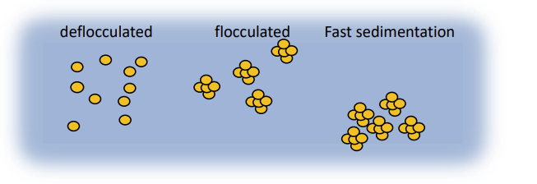

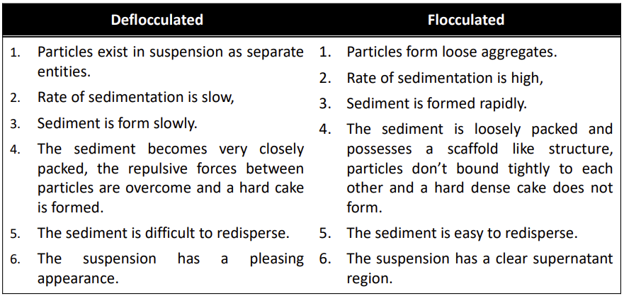

Quantitative expressions of sedimentation and flocculation

**Sedimentation Volume F:** The sedimentation volume, F, is the ratio of the equilibrium volume of the sediment,  to the total volume of the suspension 

* 
* F normally ranges from nearly 0 to 1.
* When F = 1:
* No sediment is apparent even though the system is flocculated.
* Caking also will be absent.
* The suspension is esthetically pleasing, there being no visible, clear supernatant.

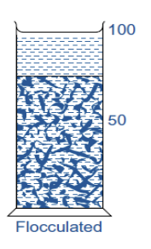

**Degree of flocculation **

* 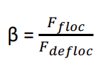
* Is a parameter for comparing flocculated systems

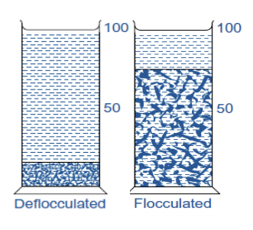

Effect of viscosity

* The traditional approach was to raise the viscosity of the dispersion medium to the point at which sedimentation is very low.
* It would be difficult to remove a dose from the container
* It decreased the rate of sedimentation, but it is impossible to halt sedimentation.
* Difficult to redisperse the sediment.

Formulation of suspension

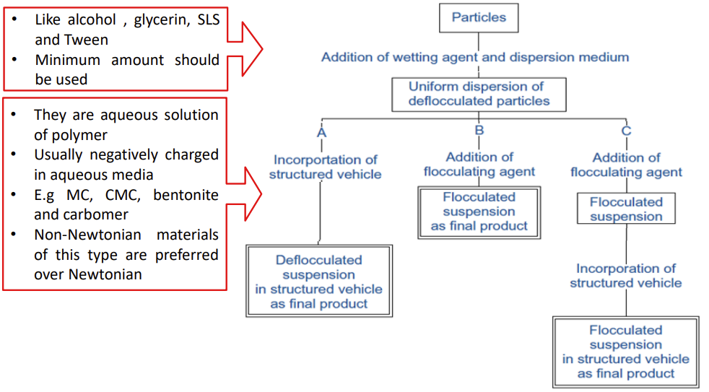

Controlled Flocculation

1. **Electrolytes**

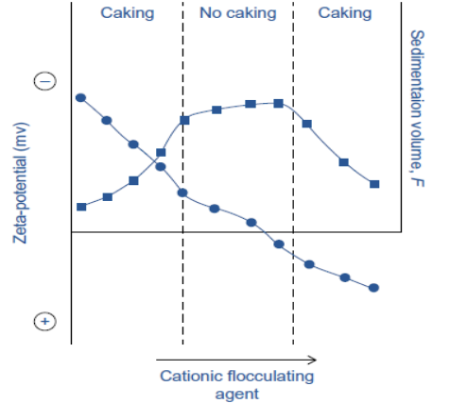

* They are the most widely used flocculating agents.
* They act by reducing the electrical forces of repulsion between particles, thereby allowing the particles to form the loose flocs.
* Example like addition of AICI3 into sulfamerazine in water which has negative charge.

1. **Polymers**

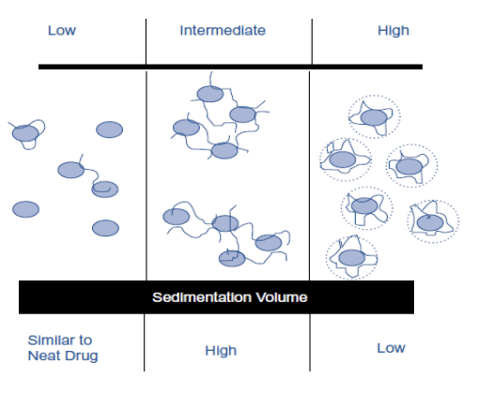

* Many Polymers contain polar functional groups that are separated by a hydrocarbon backbone.
* A polymer molecule may adsorb to particle surfaces while maintaining a degree of interaction with the solvent.

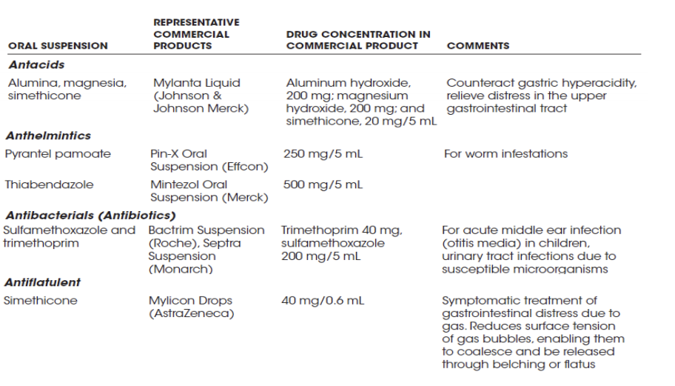

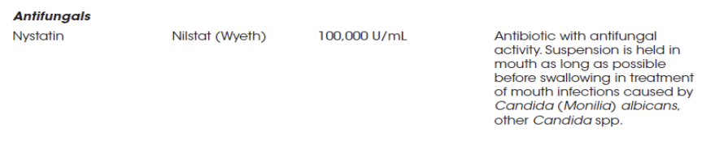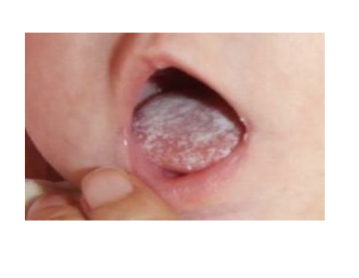

* University of Sulaimani School of Pharmacy; Pharmaceutical Compounding, Dr. rer. Nat. Rebat Ali.
* [**^**](https://en.wikipedia.org/wiki/Dispersion_(chemistry)#cite_ref-2) Richard G. Jones; Edward S. Wilks; W. Val Metanomski; Jaroslav Kahovec; Michael Hess; Robert Stepto; Tatsuki Kitayama, eds. (2009). *Compendium of Polymer Terminology and Nomenclature (IUPAC Recommendations 2008)* (2nd ed.). RSC Publ. p. 464. [ISBN](https://en.wikipedia.org/wiki/ISBN_(identifier)) [978-0-85404-491-7](https://en.wikipedia.org/wiki/Special:BookSources/978-0-85404-491-7).
* [**^**](https://en.wikipedia.org/wiki/Dispersion_(chemistry)#cite_ref-3) NALWA, H (2000), "Index for Volume 3", *Handbook of Nanostructured Materials and Nanotechnology*, Elsevier, pp. 585–591, [doi](https://en.wikipedia.org/wiki/Doi_(identifier)):[10.1016/b978-012513760-7/50068-x](https://doi.org/10.1016%2Fb978-012513760-7%2F50068-x), [ISBN](https://en.wikipedia.org/wiki/ISBN_(identifier)) [9780125137607](https://en.wikipedia.org/wiki/Special:BookSources/9780125137607)